Student’s name | …………………………………………………….…… | Grade | 1
Subject | Computer | Week No. | 13
Lesson Title | A Digital Notepad | Unit
Worksheet No. ( 13 ) (Answer)

Question A: write the correct name of each part

Windows | Enter | Paint | Escape-key
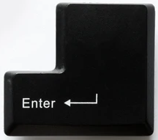

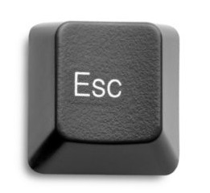

Escape-key
Paint
Enter
Windows
Good Luck

